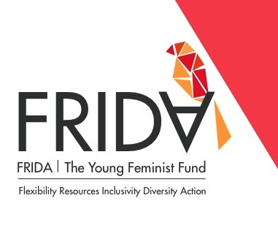
Advisory Committee Application Form

Note: please comply with the word limits for the following questions. Your completed application should not exceed 2 pages in total.

Part 1.

Personal Details
- First Name:
- Last Name:
- Gender-identity:
- Date of Birth:
- Email:
- Primary Telephone: (Please include country and area codes)
- Address:
- City:
- Country:

- Please indicate your language proficiency:
Fluent – This is my first language, OR I speak, read and write with ease
Intermediate – I can attend a workshop conducted in this language and can communicate, read and write at a functional level. I only need assistance for with complex ideas or concepts.
Basic – I can understand a little of this language, but will need a translator to assist with reading, writing and comprehension

English: Fluent Intermediate Basic
Other languages (please list):
Language 1: Fluent Intermediate Basic None
Language 2: Fluent Intermediate Basic None

Organization or Initiative you work with/for:
Note: that the term “initiative” includes collectives, associations, and other types of informal groups, programs and projects. All Advisory Committee members will serve in their personal capacity. The information below will be used to assess the suitability of candidates for the Committee.

- Initiative Name:

- Position in the initiative:

- You have been with the initiative since the year:

- Initiative Telephone: (Please include country and area codes)

- Initiative Website:

- What is the geographic scope of your organizations' work? (Check all that apply)

Local National Regional International

Additional Information

- Do you have easy access to skype, email and telephone? Yes No

- Are you able to travel? Yes No

- Do you self-identify as a feminist? Yes No

- Have you ever served or an advisory or governance board before? Yes No
If yes, please list the name(s) of the organization(s):

Part 2.

- Briefly (maximum 300 words) explain why you would like to join the Advisory Committee and describe the skills and knowledge that you would bring to the Committee.
What kind of regional or country specific perspective are you interested in sharing with the committee?
What kind of thematic perspectives (e.g. sex workers, disability rights, indigenous rights, land rights, environmental justice issues etc.) are you interested in sharing with FRIDA?

- Based on your experience, what are the main challenges and opportunities for mobilizing funds for women’s rights? [Max 200 words]

- What do you think are the key challenges for young women in organizations/movements? [Max 200 words]

- What do you think is the main challenge facing women's organizations and movements in your region? [Max 200 words]

- Please provide two names of colleagues that can provide more information about your human rights work.

