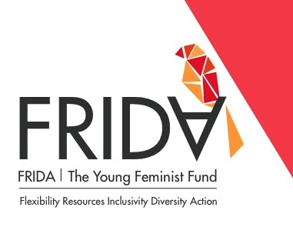
Advisory Committee Application Form

Note: please comply with the word limits for the following questions. Your completed application should not exceed 2 pages in total. Please submit this completed form along with your CV to recruitment@youngfeministfund.org. Please put “Advisory Committee” in the Subject Line.

Part 1.

Personal Details
- First Name:
- Last Name:
- Gender-identity:
- Date of Birth:
- Email:
- Primary Telephone: (Please include country and area codes)
- Address:
- City:
- Country:

- Please indicate your language proficiency:
Fluent – This is my first language, OR I speak, read and write with ease
Intermediate – I can attend a workshop conducted in this language and can communicate, read and write at a functional level. I only need assistance for with complex ideas or concepts.
Basic – I can understand a little of this language, but will need a translator to assist with reading, writing and comprehension

English: Fluent Intermediate Basic
Other languages (please list):
Language 1: Fluent Intermediate Basic None
Language 2: Fluent Intermediate Basic None

Additional Information

- Do you have easy access to skype, email and telephone? Yes No
- Are you able to travel? Yes No
- Do you self-identify as a feminist? Yes No
- Have you ever served or an advisory or governance board before? Yes No
If yes, please list the name(s) of the organization(s):

Please check up to 3 areas of FRIDA’s work you have the time and capacity to contribute to:
Grantmaking (reading proposals, supporting the FRIDA team to review groups and conduct due diligence)
Capacity-building (working with grantee partners on their capacity development plans, organizing workshops on specific topics, delivering specific support for a grantee partner)
Resource mobilization (organizing a fundraising event, connecting FRIDA to specific donors, supporting FRIDA to run a fundraising campaign)
Communications (writing blogs, running a communications campaign, making improvements to FRIDA’s online visibility)
Knowledge-building and advocacy (conducting research, designing advocacy campaigns, speaking with key networks, conferences, and spaces)
Part 2.

- Briefly introduce yourself and explain why you would like to join the Advisory Committee, clearly describing the skills and knowledge that you would contribute to FRIDA. For example regional or country specific knowledge, thematic expertise (e.g. sex workers, disability rights, indigenous rights, land rights, environmental justice issues etc.), or skills expertise (e.g. fundraising, communications, monitoring, evaluation, and learning). [Max 300 words]

- What do you think are the key challenges and opportunities for young women in organizations/movements? [Max 200 words]

- Based on your skills, interests, and passions, please define 2-3 specific goals you think you can achieve over the next 12 month period. (If you are selected as an advisor, we will discuss and refine these contributions with you - how it aligns with FRIDA’s strategy and how we can support you to achieve these goals.)

For example:
- I want to help with translation and outreach in order to ensure FRIDA receives more applications from ___ region.
- I want to run a capacity-development workshop with FRIDA grantee partners on the topic of _____.
- I want to support FRIDA’s communications and write blogs/op-eds on ______.
- I want to represent FRIDA at ____ conference in order to increase their visibility in this community.

- Please provide two names of colleagues that can provide more information about your human rights work.

